import numpy as np   
import matplotlib.pyplot as plt

#Seasons  
Seasons = ["2010","2011","2012","2013","2014","2015","2016","2017","2018","2019"]  
Sdict = {"2010":0,"2011":1,"2012":2,"2013":3,"2014":4,"2015":5,"2016":6,"2017":7,"2018":8,"2019":9}  
  
#Players  
Players = ["Sachin","Rahul","Smith","Sami","Pollard","Morris","Samson","Dhoni","Kohli","Sky"]  
Pdict = {"Sachin":0,"Rahul":1,"Smith":2,"Sami":3,"Pollard":4,"Morris":5,"Samson":6,"Dhoni":7,"Kohli":8,"Sky":9}  
  
#Salaries  
Sachin_Salary = [15946875,17718750,19490625,21262500,23034375,24806250,25244493,27849149,30453805,23500000]  
Rahul_Salary = [12000000,12744189,13488377,14232567,14976754,16324500,18038573,19752645,21466718,23180790]  
Smith_Salary = [4621800,5828090,13041250,14410581,15779912,14500000,16022500,17545000,19067500,20644400]  
Sami_Salary = [3713640,4694041,13041250,14410581,15779912,17149243,18518574,19450000,22407474,22458000]  
Pollard_Salary = [4493160,4806720,6061274,13758000,15202590,16647180,18091770,19536360,20513178,21436271]  
Morris_Salary = [3348000,4235220,12455000,14410581,15779912,14500000,16022500,17545000,19067500,20644400]  
Samson_Salary = [3144240,3380160,3615960,4574189,13520500,14940153,16359805,17779458,18668431,20068563]  
Dhoni_Salary = [0,0,4171200,4484040,4796880,6053663,15506632,16669630,17832627,18995624]  
Kohli_Salary = [0,0,0,4822800,5184480,5546160,6993708,16402500,17632688,18862875]  
Sky_Salary = [3031920,3841443,13041250,14410581,15779912,14200000,15691000,17182000,18673000,15000000]  
  
#Matrix  
Salary = np.array([Sachin_Salary, Rahul_Salary, Smith_Salary, Sami_Salary, Pollard_Salary, Morris_Salary, Samson_Salary, Dhoni_Salary, Kohli_Salary, Sky_Salary])  
  
#Games   
Sachin_G = [80,77,82,82,73,82,58,78,6,35]  
Rahul_G = [82,57,82,79,76,72,60,72,79,80]  
Smith_G = [79,78,75,81,76,79,62,76,77,69]  
Sami_G = [80,65,77,66,69,77,55,67,77,40]  
Pollard_G = [82,82,82,79,82,78,54,76,71,41]  
Morris_G = [70,69,67,77,70,77,57,74,79,44]  
Samson_G = [78,64,80,78,45,80,60,70,62,82]  
Dhoni_G = [35,35,80,74,82,78,66,81,81,27]  
Kohli_G = [40,40,40,81,78,81,39,0,10,51]  
Sky_G = [75,51,51,79,77,76,49,69,54,62]  
#Matrix  
Games = np.array([Sachin_G, Rahul_G, Smith_G, Sami_G, Pollard_G, Morris_G, Samson_G, Dhoni_G, Kohli_G, Sky_G])  
  
#Points  
Sachin_PTS = [2832,2430,2323,2201,1970,2078,1616,2133,83,782]  
Rahul_PTS = [1653,1426,1779,1688,1619,1312,1129,1170,1245,1154]  
Smith_PTS = [2478,2132,2250,2304,2258,2111,1683,2036,2089,1743]  
Sami_PTS = [2122,1881,1978,1504,1943,1970,1245,1920,2112,966]  
Pollard_PTS = [1292,1443,1695,1624,1503,1784,1113,1296,1297,646]  
Morris_PTS = [1572,1561,1496,1746,1678,1438,1025,1232,1281,928]  
Samson_PTS = [1258,1104,1684,1781,841,1268,1189,1186,1185,1564]  
Dhoni_PTS = [903,903,1624,1871,2472,2161,1850,2280,2593,686]  
Kohli_PTS = [597,597,597,1361,1619,2026,852,0,159,904]  
Sky_PTS = [2040,1397,1254,2386,2045,1941,1082,1463,1028,1331]  
#Matrix  
Points = np.array([Sachin_PTS, Rahul_PTS, Smith_PTS, Sami_PTS, Pollard_PTS, Morris_PTS, Samson_PTS, Dhoni_PTS, Kohli_PTS, Sky_PTS])

Salary

array([[15946875, 17718750, 19490625, 21262500, 23034375, 24806250,  
 25244493, 27849149, 30453805, 23500000],  
 [12000000, 12744189, 13488377, 14232567, 14976754, 16324500,  
 18038573, 19752645, 21466718, 23180790],  
 [ 4621800, 5828090, 13041250, 14410581, 15779912, 14500000,  
 16022500, 17545000, 19067500, 20644400],  
 [ 3713640, 4694041, 13041250, 14410581, 15779912, 17149243,  
 18518574, 19450000, 22407474, 22458000],  
 [ 4493160, 4806720, 6061274, 13758000, 15202590, 16647180,  
 18091770, 19536360, 20513178, 21436271],  
 [ 3348000, 4235220, 12455000, 14410581, 15779912, 14500000,  
 16022500, 17545000, 19067500, 20644400],  
 [ 3144240, 3380160, 3615960, 4574189, 13520500, 14940153,  
 16359805, 17779458, 18668431, 20068563],  
 [ 0, 0, 4171200, 4484040, 4796880, 6053663,  
 15506632, 16669630, 17832627, 18995624],  
 [ 0, 0, 0, 4822800, 5184480, 5546160,  
 6993708, 16402500, 17632688, 18862875],  
 [ 3031920, 3841443, 13041250, 14410581, 15779912, 14200000,  
 15691000, 17182000, 18673000, 15000000]])

Games

array([[80, 77, 82, 82, 73, 82, 58, 78, 6, 35],  
 [82, 57, 82, 79, 76, 72, 60, 72, 79, 80],  
 [79, 78, 75, 81, 76, 79, 62, 76, 77, 69],  
 [80, 65, 77, 66, 69, 77, 55, 67, 77, 40],  
 [82, 82, 82, 79, 82, 78, 54, 76, 71, 41],  
 [70, 69, 67, 77, 70, 77, 57, 74, 79, 44],  
 [78, 64, 80, 78, 45, 80, 60, 70, 62, 82],  
 [35, 35, 80, 74, 82, 78, 66, 81, 81, 27],  
 [40, 40, 40, 81, 78, 81, 39, 0, 10, 51],  
 [75, 51, 51, 79, 77, 76, 49, 69, 54, 62]])

Points

array([[2832, 2430, 2323, 2201, 1970, 2078, 1616, 2133, 83, 782],  
 [1653, 1426, 1779, 1688, 1619, 1312, 1129, 1170, 1245, 1154],  
 [2478, 2132, 2250, 2304, 2258, 2111, 1683, 2036, 2089, 1743],  
 [2122, 1881, 1978, 1504, 1943, 1970, 1245, 1920, 2112, 966],  
 [1292, 1443, 1695, 1624, 1503, 1784, 1113, 1296, 1297, 646],  
 [1572, 1561, 1496, 1746, 1678, 1438, 1025, 1232, 1281, 928],  
 [1258, 1104, 1684, 1781, 841, 1268, 1189, 1186, 1185, 1564],  
 [ 903, 903, 1624, 1871, 2472, 2161, 1850, 2280, 2593, 686],  
 [ 597, 597, 597, 1361, 1619, 2026, 852, 0, 159, 904],  
 [2040, 1397, 1254, 2386, 2045, 1941, 1082, 1463, 1028, 1331]])

%matplotlib inline

Salary[0]

array([15946875, 17718750, 19490625, 21262500, 23034375, 24806250,  
 25244493, 27849149, 30453805, 23500000])

plt.plot(Salary[0])

[<matplotlib.lines.Line2D at 0x2062f423460>]

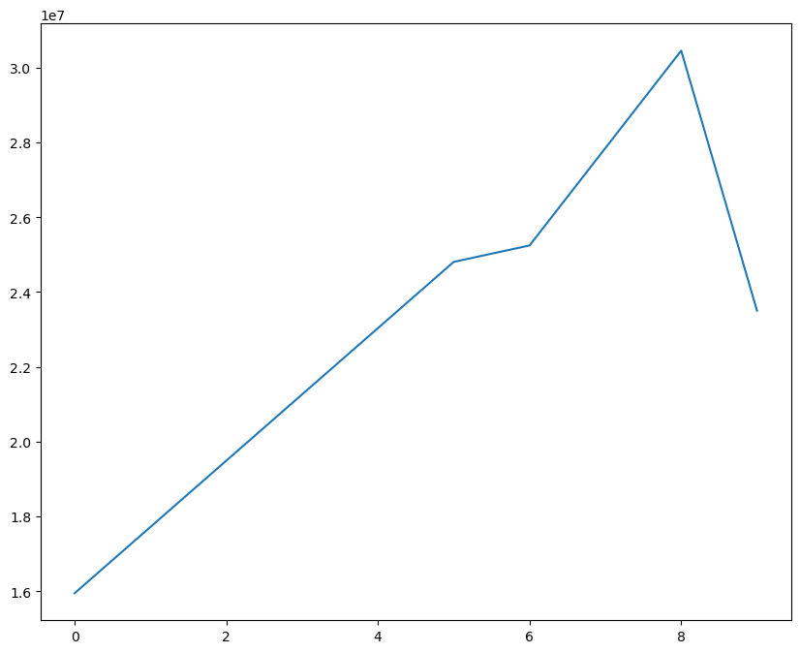

plt.plot(Salary[0], c='red')

[<matplotlib.lines.Line2D at 0x2062f428be0>]

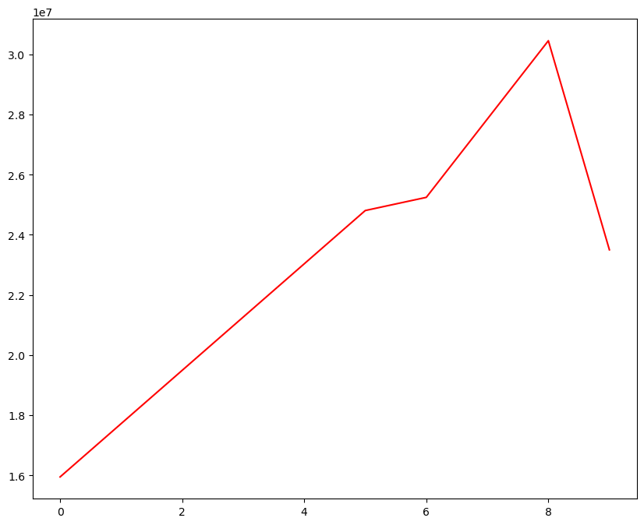

plt.plot(Salary[0], c='Green', ls = '--', marker = 's', ms = 10)  
plt.show()

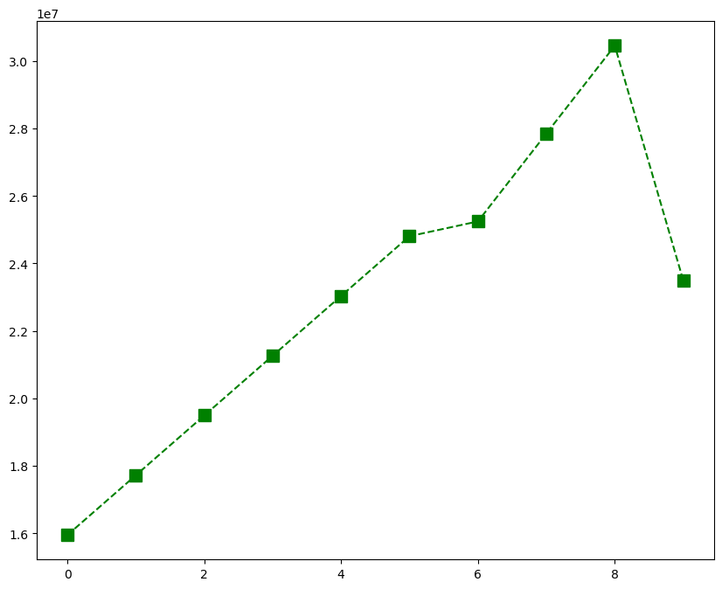

Salary[1]

array([12000000, 12744189, 13488377, 14232567, 14976754, 16324500,  
 18038573, 19752645, 21466718, 23180790])

plt.plot(Salary[1], c='Blue', ls = ':', marker = 'o', ms = 10, label = Players[1])

[<matplotlib.lines.Line2D at 0x2062fcbf7c0>]

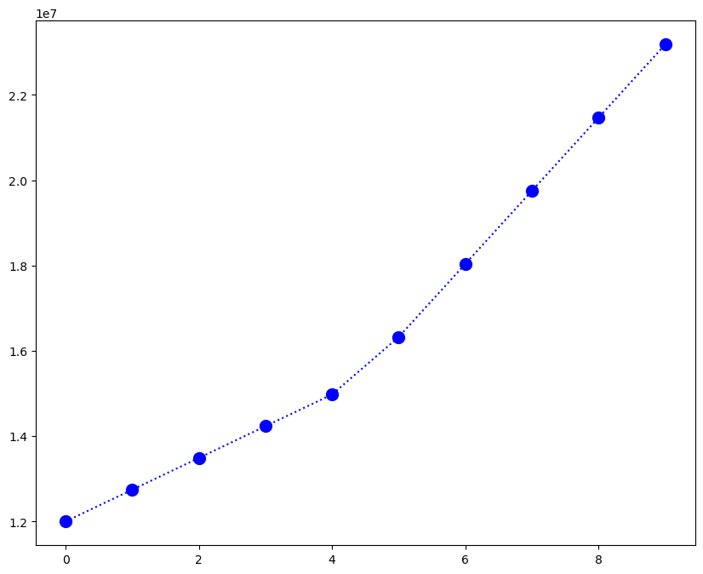

plt.plot(Salary[0], c='Green', ls = '--', marker = 's', ms = 10, label = Players[0])  
plt.plot(Salary[1], c='Blue', ls = ':', marker = 'o', ms = 10, label = Players[1])  
  
plt.xticks(list(range(0,10)), Seasons,rotation='vertical')  
  
plt.show()

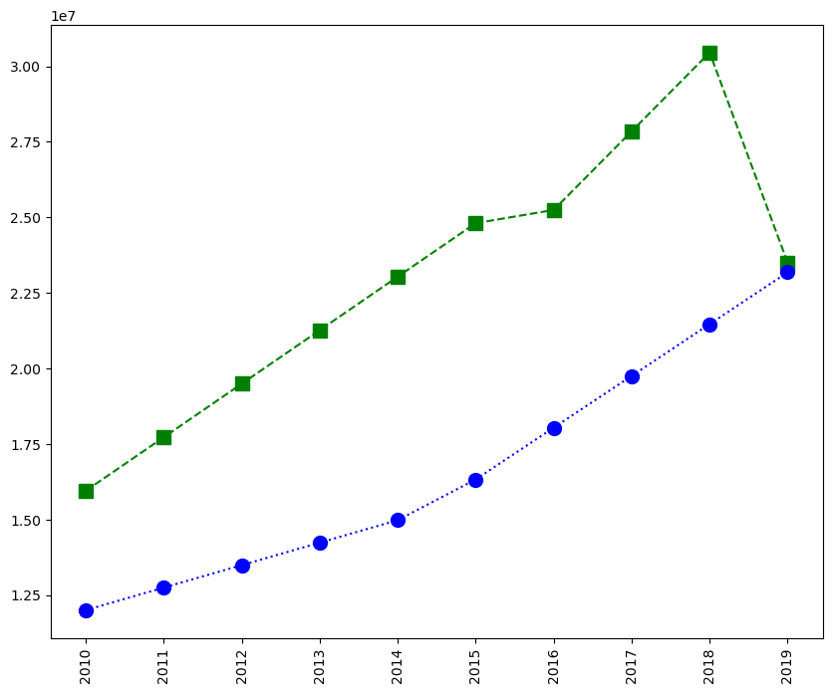

plt.plot(Salary[0], c='Green', ls = '--', marker = 's', ms = 7, label = Players[0])  
plt.plot(Salary[1], c='Blue', ls = '--', marker = 'o', ms = 5, label = Players[1])  
plt.plot(Salary[2], c='purple', ls = '--', marker = '^', ms = 8, label = Players[2])  
  
  
plt.xticks(list(range(0,10)), Seasons,rotation='vertical')  
  
plt.show()

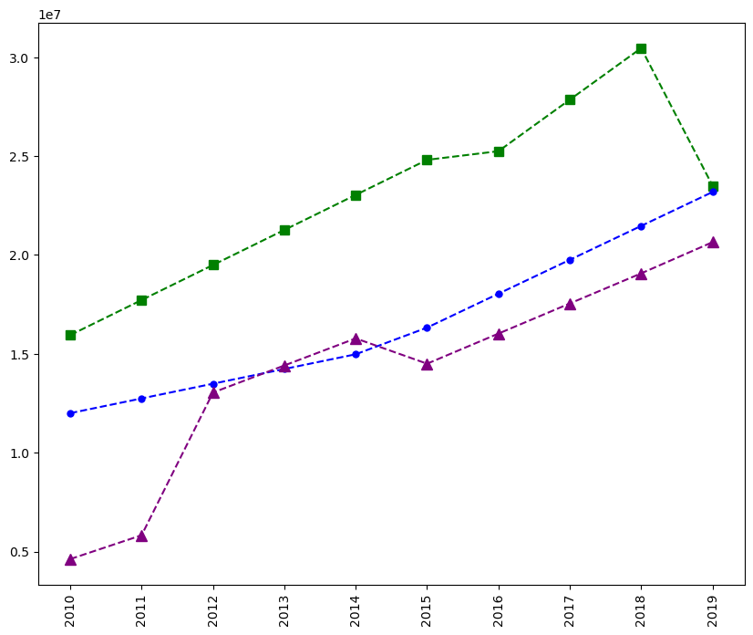

plt.plot(Salary[0], c='Green', ls = '--', marker = 's', ms = 7, label = Players[0])  
plt.plot(Salary[1], c='Blue', ls = '-', marker = 'o', ms = 5, label = Players[1])  
plt.plot(Salary[2], c='purple', ls = '--', marker = '^', ms = 8, label = Players[2])  
plt.plot(Salary[3], c='Red', ls = ':', marker = 'd', ms = 8, label = Players[3])  
  
plt.xticks(list(range(0,10)), Seasons,rotation='vertical')  
  
plt.show()

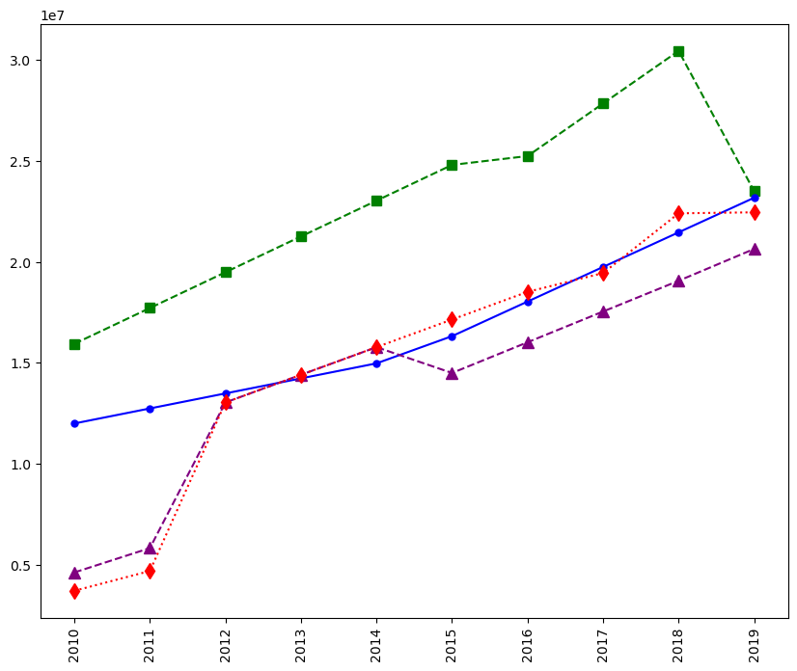

plt.plot(Salary[0], c='Green', ls = '--', marker = 's', ms = 7, label = Players[0])  
plt.plot(Salary[1], c='Blue', ls = ':', marker = 'o', ms = 5, label = Players[1])  
plt.plot(Salary[2], c='purple', ls = '-', marker = '^', ms = 8, label = Players[2])  
plt.plot(Salary[3], c='Red', ls = '--', marker = 'd', ms = 8, label = Players[3])  
plt.legend()   
plt.xticks(list(range(0,10)), Seasons,rotation='vertical')  
  
plt.show()

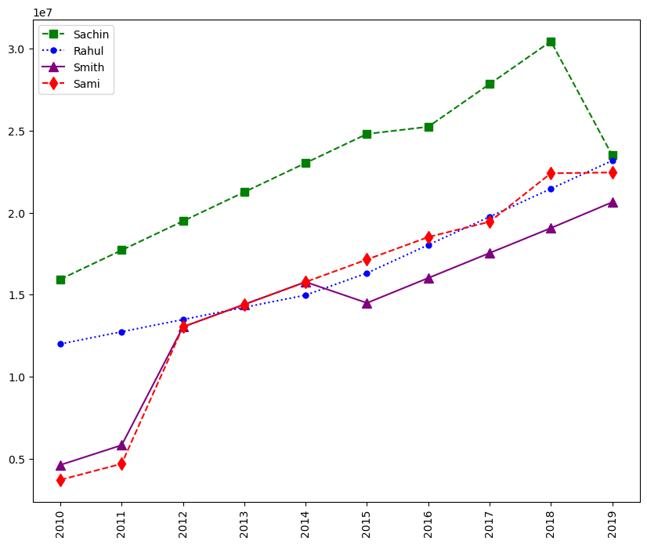

plt.plot(Salary[0], c='Green', ls = '--', marker = 's', ms = 7, label = Players[0])  
plt.plot(Salary[1], c='Blue', ls = '--', marker = 'o', ms = 5, label = Players[1])  
plt.plot(Salary[2], c='purple', ls = '--', marker = '^', ms = 8, label = Players[2])  
plt.plot(Salary[3], c='Red', ls = '--', marker = 'd', ms = 8, label = Players[3])  
plt.legend(loc = 'upper left',bbox_to_anchor=(0,0) )   
plt.xticks(list(range(0,10)), Seasons,rotation='vertical')  
  
plt.show()

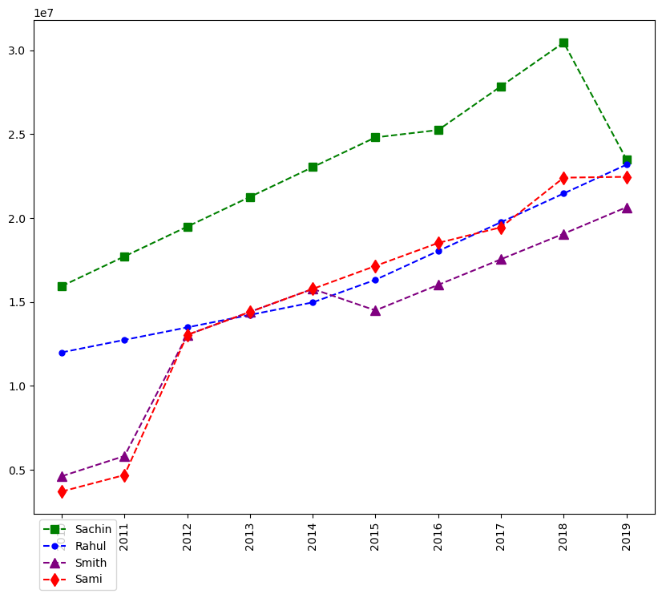

plt.plot(Salary[0], c='Green', ls = '--', marker = 's', ms = 7, label = Players[0])  
plt.plot(Salary[1], c='Blue', ls = '--', marker = 'o', ms = 5, label = Players[1])  
plt.plot(Salary[2], c='Green', ls = '--', marker = '^', ms = 8, label = Players[2])  
plt.plot(Salary[3], c='Red', ls = '--', marker = 'd', ms = 8, label = Players[3])  
plt.legend(loc = 'upper right',bbox_to_anchor=(1,0) )  
plt.xticks(list(range(0,10)), Seasons,rotation='vertical')  
  
plt.show()

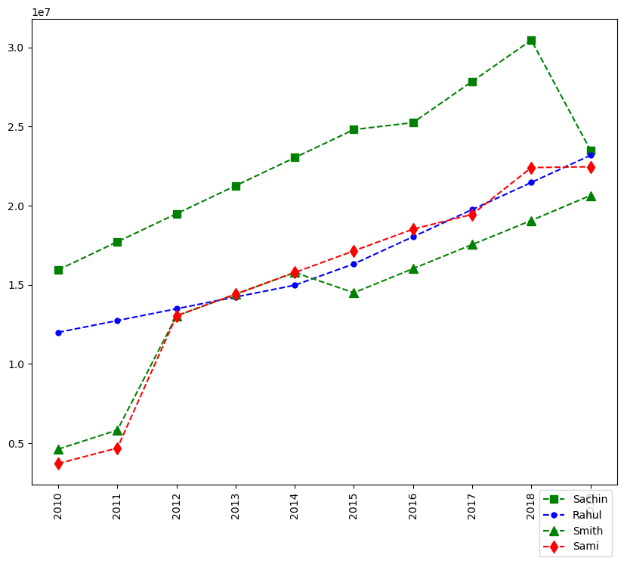

plt.plot(Games[0], c='Green', ls = '--', marker = 's', ms = 7, label = Players[0])  
plt.plot(Games[1], c='Blue', ls = '--', marker = 'o', ms = 7, label = Players[1])  
plt.plot(Games[2], c='Green', ls = '--', marker = '^', ms = 7, label = Players[2])  
plt.plot(Games[3], c='Red', ls = '--', marker = 'D', ms = 7, label = Players[3])  
plt.plot(Games[4], c='Black', ls = '--', marker = 's', ms = 7, label = Players[4])  
plt.plot(Games[5], c='Blue', ls = '--', marker = 'o', ms = 7, label = Players[5])  
plt.plot(Games[6], c='red', ls = '--', marker = '^', ms = 7, label = Players[6])  
plt.plot(Games[7], c='Green', ls = '--', marker = 'd', ms = 7, label = Players[7])  
plt.plot(Games[8], c='Red', ls = '--', marker = 's', ms = 7, label = Players[8])  
plt.plot(Games[9], c='Blue', ls = '--', marker = 'o', ms = 7, label = Players[9])  
  
plt.legend(loc = 'lower right',bbox_to_anchor=(0.5,1) )  
plt.xticks(list(range(0,10)), Seasons,rotation='vertical')  
  
plt.show()

